Dokumen Agile

Edbert Eddyson Gunawan 13522039

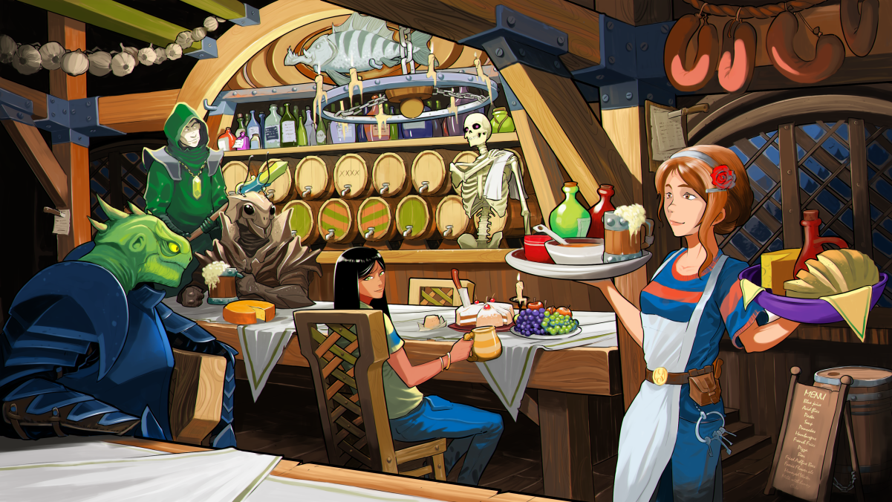

– another fav novel of mine: The Wandering Inn

Made With Love ❤️‍🔥

# Daftar Isi

**Daftar Isi** **2**

**Definition of Done** **3**

**Product Backlog** **3**

**Sprint Backlog** **5**

Sprint 1 (21 Juli - 03 Agustus 2024) 5

Sprint 2 (04 Agustus - 17 Agustus 2024) 5

Sprint 3 (18 Agustus - 2 September 2024) 6

**Planning?** **7**

**Status** **7**

# Definition of Done

Sebuah tugas atau soal dianggap selesai jika semua kriteria berikut telah terpenuhi:

* Semua spesifikasi wajib yang ditetapkan dalam user story telah diselesaikan dan divalidasi.
* Dokumentasi yang diperlukan, termasuk documentation kode dan user guide (jika diperlukan), telah diperbarui dan diselesaikan.
* Tidak ada bug kritis atau blocker yang belum terselesaikan.

Jika terdapat spek tambahan atau bonus, pengerjaannya dianggap sebagai tambahan nilai namun tidak mempengaruhi status done dari tugas utama.

# Product Backlog

| Kode | Nama Soal |
| --- | --- |
| S01 | Agile-Schizo / Agile-Sister / Agile-Scum / #AJEGILE |
| S02 | What you're refering to as Linux, is in fact, GNU/Linux |
| S03 | 2 nm TranSISTER |
| S04 | Cisco 🅱️acket Tracer: Of Routers and Switches |
| S05 | Wolfman|Sigma |
| S06 | McLaren Lo Warna Apa Bos? |
| S07 | monkeDB |
| S08 | Carpal Tunnel Syndrome |
| S09 | Capture The Flag: CRY, REV, and PWN edition |
| S10 | SISTER.Js |
| S11 | Jancuk Pristail |
| S12 | Benchmarking |
| S13 | Fotosop |
| S14 | I am Dripping |
| S15 | Pelabuhan |
| S16 | BMI - Belajar Matematika Isekai |
| S17 | Klak-klak-klakulator: "Help! I accidentally summoned Cthulhu!" Edition |
| S18 | TTKI - Tulis Tulis Karya Imajinasi |

# Sprint Backlog

## Sprint 1 (21 Juli - 03 Agustus 2024)

| **Kode** | **Nama Soal** |
| --- | --- |
| S07 | monkeDB |
| S17 | Klak-klak-klakulator: "Help! I accidentally summoned Cthulhu!" Edition |
| S18 | TTKI - Tulis Tulis Karya Imajinasi |
| S08 | Carpal Tunnel Syndrome |
| S09 | Capture The Flag: CRY, REV, and PWN edition |

### Kanban Board

Progress 1

| **Kode** | **Nama Soal** | **Status** |
| --- | --- | --- |
| S07 | monkeDB | in progress |
| S17 | Klak-klak-klakulator: "Help! I accidentally summoned Cthulhu!" Edition | blocked |
| S18 | TTKI - Tulis Tulis Karya Imajinasi | blocked |
| S08 | Carpal Tunnel Syndrome | blocked |
| S09 | Capture The Flag: CRY, REV, and PWN edition | blocked |

Progress 2

| **Kode** | **Nama Soal** | **Status** |
| --- | --- | --- |
| S07 | monkeDB | done |
| S17 | Klak-klak-klakulator: "Help! I accidentally summoned Cthulhu!" Edition | in progress |
| S18 | TTKI - Tulis Tulis Karya Imajinasi | blocked |
| S08 | Carpal Tunnel Syndrome | blocked |
| S09 | Capture The Flag: CRY, REV, and PWN edition | blocked |

Progress 3

| **Kode** | **Nama Soal** | **Status** |
| --- | --- | --- |
| S07 | monkeDB | done |
| S17 | Klak-klak-klakulator: "Help! I accidentally summoned Cthulhu!" Edition | in progress |
| S18 | TTKI - Tulis Tulis Karya Imajinasi | in progress |
| S08 | Carpal Tunnel Syndrome | blocked |
| S09 | Capture The Flag: CRY, REV, and PWN edition | blocked |

Progress 4

| **Kode** | **Nama Soal** | **Status** |
| --- | --- | --- |
| S07 | monkeDB | done |
| S17 | Klak-klak-klakulator: "Help! I accidentally summoned Cthulhu!" Edition | done |
| S18 | TTKI - Tulis Tulis Karya Imajinasi | done |
| S08 | Carpal Tunnel Syndrome | in progress |
| S09 | Capture The Flag: CRY, REV, and PWN edition | blocked |

Progress 5

| **Kode** | **Nama Soal** | **Status** |
| --- | --- | --- |
| S07 | monkeDB | done |
| S17 | Klak-klak-klakulator: "Help! I accidentally summoned Cthulhu!" Edition | done |
| S18 | TTKI - Tulis Tulis Karya Imajinasi | done |
| S08 | Carpal Tunnel Syndrome | done |
| S09 | Capture The Flag: CRY, REV, and PWN edition | in progress |

### Sprint Review

The following table depict the final result of this sprint

| **Kode** | **Nama Soal** | **Status** |
| --- | --- | --- |
| S07 | monkeDB | done |
| S17 | Klak-klak-klakulator: "Help! I accidentally summoned Cthulhu!" Edition | done |
| S18 | TTKI - Tulis Tulis Karya Imajinasi | done |
| S08 | Carpal Tunnel Syndrome | done |
| S09 | Capture The Flag: CRY, REV, and PWN edition | in progress |

### Sprint Retrospective

Through the sprint 1, we have done most of the task, and progressing on the CTF Challenge. We have learnt

1. Setup replicating database
2. Setup openvpn
3. Perl programming
4. Pogressing slowly in CTF due to its difficulty

## Sprint 2 (04 Agustus - 17 Agustus 2024)

| **Kode** | **Nama Soal** |
| --- | --- |
| S09 | Capture The Flag: CRY, REV, and PWN edition |
| S10 | SISTER.Js |
| S12 | Benchmarking |
| S02 | What you're refering to as Linux, is in fact, GNU/Linux |
| S05 | Wolfman|Sigma |

### Kanban Board

Progress 1

| **Kode** | **Nama Soal** | **Status** |
| --- | --- | --- |
| S09 | Capture The Flag: CRY, REV, and PWN edition | in progress |
| S10 | SISTER.Js | in progress |
| S12 | Benchmarking | blocked |
| S02 | What you're refering to as Linux, is in fact, GNU/Linux | blocked |
| S05 | Wolfman|Sigma | blocked |

Progress 2

| **Kode** | **Nama Soal** | **Status** |
| --- | --- | --- |
| S09 | Capture The Flag: CRY, REV, and PWN edition | in progress |
| S10 | SISTER.Js | in progress |
| S12 | Benchmarking | blocked |
| S02 | What you're refering to as Linux, is in fact, GNU/Linux | in progress |
| S05 | Wolfman|Sigma | blocked |

Progess 3

| **Kode** | **Nama Soal** | **Status** |
| --- | --- | --- |
| S09 | Capture The Flag: CRY, REV, and PWN edition | in progress |
| S10 | SISTER.Js | in progress |
| S12 | Benchmarking | blocked |
| S02 | What you're refering to as Linux, is in fact, GNU/Linux | done |
| S05 | Wolfman|Sigma | blocked |

Progess 4

| **Kode** | **Nama Soal** | **Status** |
| --- | --- | --- |
| S09 | Capture The Flag: CRY, REV, and PWN edition | in progress |
| S10 | SISTER.Js | done |
| S12 | Benchmarking | in progress |
| S02 | What you're refering to as Linux, is in fact, GNU/Linux | done |
| S05 | Wolfman|Sigma | blocked |

Progress 5

| **Kode** | **Nama Soal** | **Status** |
| --- | --- | --- |
| S09 | Capture The Flag: CRY, REV, and PWN edition | in progress |
| S10 | SISTER.Js | done |
| S12 | Benchmarking | in progress |
| S02 | What you're refering to as Linux, is in fact, GNU/Linux | done |
| S05 | Wolfman|Sigma | in progress |

### Sprint Review

The final result of this sprint

| **Kode** | **Nama Soal** | **Status** |
| --- | --- | --- |
| S09 | Capture The Flag: CRY, REV, and PWN edition | in progress |
| S10 | SISTER.Js | done |
| S12 | Benchmarking | in progress |
| S02 | What you're refering to as Linux, is in fact, GNU/Linux | done |
| S05 | Wolfman|Sigma | in progress |

### Sprint Retrospective

What we have learned

1. Easy level AES OFB challenge using XOR.
2. Easy level of reverse engineering
3. Creating web server using C, imitating Flask
4. Gauss jordan in 2 languages
5. Installing linux wayland
6. Multiprocessing matrix multiplication in python

### 

## Sprint 3 (18 Agustus - 2 September 2024)

| **Kode** | **Nama Soal** |
| --- | --- |
| S11 | Jancuk Pristail |
| S14 | I am Dripping |
| S15 | Pelabuhan |
| S16 | BMI - Belajar Matematika Isekai |
| S01 | Agile-Schizo / Agile-Sister / Agile-Scrum / #AJEGILE |

### Kanban Board

Progress 1

| **Kode** | **Nama Soal** | **Status** |
| --- | --- | --- |
| S11 | Jancuk Pristail | in progress |
| S14 | I am Dripping | in progress |
| S15 | Pelabuhan | blocked |
| S16 | BMI - Belajar Matematika Isekai | blocked |
| S01 | Agile-Schizo / Agile-Sister / Agile-Scum / #AJEGILE | blocked |

Progress 2

| **Kode** | **Nama Soal** | **Status** |
| --- | --- | --- |
| S11 | Jancuk Pristail | done |
| S14 | I am Dripping | done |
| S15 | Pelabuhan | in progress |
| S16 | BMI - Belajar Matematika Isekai | in progress |
| S01 | Agile-Schizo / Agile-Sister / Agile-Scum / #AJEGILE | blocked |

Progress 3

| **Kode** | **Nama Soal** | **Status** |
| --- | --- | --- |
| S11 | Jancuk Pristail | done |
| S14 | I am Dripping | done |
| S15 | Pelabuhan | done |
| S16 | BMI - Belajar Matematika Isekai | in progress |
| S01 | Agile-Schizo / Agile-Sister / Agile-Scum / #AJEGILE | done |

Progress 4

| **Kode** | **Nama Soal** | **Status** |
| --- | --- | --- |
| S11 | Jancuk Pristail | done |
| S14 | I am Dripping | done |
| S15 | Pelabuhan | done |
| S16 | BMI - Belajar Matematika Isekai | done |
| S01 | Agile-Schizo / Agile-Sister / Agile-Scum / #AJEGILE | done |

Progress 5

| **Kode** | **Nama Soal** | **Status** |
| --- | --- | --- |
| S11 | Jancuk Pristail | done |
| S14 | I am Dripping | done |
| S15 | Pelabuhan | done |
| S16 | BMI - Belajar Matematika Isekai | done |
| S01 | Agile-Schizo / Agile-Sister / Agile-Scum / #AJEGILE | done |

### Sprint Review

Final result table

| **Kode** | **Nama Soal** | **Status** |
| --- | --- | --- |
| S11 | Jancuk Pristail | done |
| S14 | I am Dripping | done |
| S15 | Pelabuhan | done |
| S16 | BMI - Belajar Matematika Isekai | done |
| S01 | Agile-Schizo / Agile-Sister / Agile-Scum / #AJEGILE | done |

### Sprint Retrospective

Based on this sprint, i learned

1. Pentesting a box
2. Running Kubernetes
3. Setting up three tier application
4. Reading ARM asm
5. Using AGILE SCRUM

# Appendix

| **Kode** | **Nama Soal** |
| --- | --- |
| S01 | Agile-Schizo / Agile-Sister / Agile-Scum / #AJEGILE |
| S02 | What you're refering to as Linux, is in fact, GNU/Linux |
| S03 | 2 nm TranSISTER |
| S04 | Cisco 🅱️acket Tracer: Of Routers and Switches |
| S05 | Wolfman|Sigmaw |
| S06 | McLaren Lo Warna Apa Bos? |
| S07 | monkeDB |
| S08 | Carpal Tunnel Syndrome |
| S09 | Capture The Flag: CRY, REV, and PWN edition |
| S10 | SISTER.Js |
| S11 | Jancuk Pristail |
| S12 | Benchmarking |
| S13 | Fotosop |
| S14 | I am Dripping |
| S15 | Pelabuhan |
| S16 | BMI - Belajar Matematika Isekai |
| S17 | Klak-klak-klakulator: "Help! I accidentally summoned Cthulhu!" Edition |
| S18 | TTKI - Tulis Tulis Karya Imajinasi |